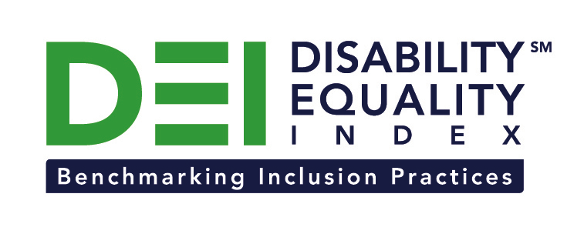

Press Release

WellPoint Joins the Disability Equality Index as a Founding Partner

Company joins American Airlines, Comcast / NBCUniversal, CVS Health, Dupont, GlaxoSmithKline (GSK), New Editions Consulting, Inc., and Northrop Grumman Corporation to support launch of online tool to measure businesses’ inclusion of people with disabilities

For Immediate Release Contact: Anita Howard
September 29, 2014 Phone: (800) 706-2710 anita@usbln.org

Washington, DC (September 29, 2014) -- Today, the US Business Leadership Network® (USBLN®) and the American Association of People with Disabilities (AAPD) are pleased to announce that WellPoint, Inc. joined as a Founding Partner of the USBLN and AAPD’s new Disability Equality IndexSM (DEISM), an online tool that offers businesses the opportunity to objectively measure their full inclusion of people with disabilities as employees, suppliers, and customers.

“We are thrilled to have WellPoint join us on this groundbreaking initiative for the business and disability communities,” said Jill Houghton, Executive Director of the USBLN. “By joining as a DEI Founding Partner, WellPoint is showcasing their support of disability inclusive practices throughout corporate America,” said Mark Perriello, President and CEO of AAPD.

Created by leaders in the business and disability communities, and after the successful completion of the DEI pilot with 48 Fortune 1000 scope companies in March 2014, the first Annual DEI will launch to Fortune 1000 companies in October 2014.

The DEI is a benchmarking tool that offers businesses the opportunity to receive an objective score on their disability inclusion policies and practices, and identify avenues for continued improvement. Companies self-report on a wide-range of criteria within four categories: Culture & Leadership, Enterprise-Wide Access, Employment Practices, and Community Engagement & Support Services.

“It is an honor for WellPoint to be part of this select group of employers who are leading a transformational effort that will allow millions of people with disabilities to effectively contribute as part of the workforce and as empowered members of our society, said Tracy Edmonds, chief diversity officer for WellPoint. “Many of WellPoint’s customers and associates are individuals with disabilities and, by joining the DEI as Founding Partners we are letting them know that we are committed to being an inclusive organization for our associates, for those with whom we do business and, to developing business solutions and services that effectively address the needs of this segment.”

WellPoint’s commitment to a diverse workforce and an inclusive culture are evidenced by tangible efforts to promote the employment and advancement of people with disabilities. Through key partnerships with leading organizations they have developed and implemented practices and programs that seek to employ and leverage the talents of people with disabilities. One of those efforts is represented by ABLE, the company’s associate resource group for people with disabilities. Through ABLE they are developing leaders, promoting role models and, they are leveraging insights and personal experiences that help them refine business solutions to better serve their customers with disabilities. Additionally, ABLE, has been instrumental in the development of programs to raise awareness and understanding of best practices and disability etiquette.
_______________________________________________________________________________________

The DEI Founding Partner status is a one-time opportunity exclusive to the first 15 companies that join before December 31, 2015. To date, DEI Founding Partners include American Airlines, Comcast and NBCUniversal, CVS Health, Dupont, GSK, New Editions Consulting, Inc., Northrop Grumman Corporation, and WellPoint, Inc. Companies interested in learning more about becoming a DEI Founding Partner should contact Liz Taub, USBLN Director, Business Relations & Strategic Partnerships, at liz@usbln.org.

For more information about the DEI, please visit: http://www.usbln.org/programs-dei.html.

About the US Business Leadership Network® (USBLN®)
The US Business Leadership Network® (USBLN®) is a national non-profit that helps business drive performance by leveraging disability inclusion in the workplace, supply chain, and marketplace. The USBLN® serves as the collective voice of over 50 Business Leadership Network affiliates across the United States, representing over 5,000 businesses. Additionally, the USBLN® Disability Supplier Diversity Program® (DSDP) is the nation’s leading third party certification program for disability-owned businesses, including businesses owned by service-disabled veterans. www.usbln.org

About the American Association of People with Disabilities (AAPD)
The American Association of People with Disabilities is the nation's largest disability rights organization. AAPD promotes equal opportunity, economic power, independent living, and political participation for people with disabilities. AAPD’s members, including people with disabilities and family, friends, and supporters, represent a powerful force for change. To learn more, visit the AAPD Web site: www.aapd.com.
About WellPoint, Inc.
WellPoint is working to transform health care with trusted and caring solutions. Our health plan companies deliver quality products and services that give their members access to the care they need. With nearly 69 million people served by its affiliated companies, including more than 37 million enrolled in its family of health plans, WellPoint is one of nation’s leading health benefits companies. WellPoint companies serve members as the Blue Cross licensee for California; and as the Blue Cross and Blue Shield licensees for Colorado, Connecticut, Georgia, Indiana, Kentucky, Maine, Missouri (excluding 30 counties in the Kansas City area), Nevada, New Hampshire, New York (as the Blue Cross Blue Shield licensee in 10 New York City metropolitan and surrounding counties and as the Blue Cross or Blue Cross Blue Shield licensee in selected upstate counties only), Ohio, Virginia (excluding the Northern Virginia suburbs of Washington, D.C.), and Wisconsin. In most of these service areas, WellPoint does business as Anthem Blue Cross, Anthem Blue Cross and Blue Shield, Blue Cross and Blue Shield of Georgia and Empire Blue Cross Blue Shield, or Empire Blue Cross (in the New York service areas). It also serves customers in other states through its Amerigroup, CareMore and UniCare subsidiaries. To find out more about WellPoint, go to wellpoint.com.

# # #

