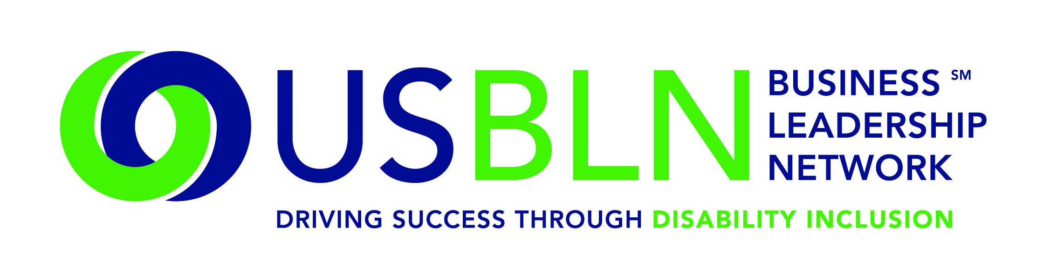
Highmark Inc. of Pa. and Highmark Del. Help to Launch America's First Disability Rights Museum on Wheels
For Immediate Release Contact: Shawna Berger
July 9, 2015 Phone: (800) 706-2710 shawna@usbln.org
WASHINGTON, D.C. (July 9, 2015) - Today, the US Business Leadership Network® (USBLN®) officially announced that Highmark Inc. of Pa. and Highmark Del. have come on board as Tour Partners of America's Disability Rights Museum on Wheels (DRMW), the country's first disability rights mobile museum.
The DRMW is an accessible self-contained motor vehicle, featuring interactive learning opportunities and emerging technologies to assist those with disabilities. The mobile museum cross-country tour began in June in Charlotte, N.C. and continues through 2016. The DRMW provides a unique opportunity to learn the fascinating history of the disability rights movement. It presents an eye-catching exhibit that invites the visitor to participate in hands-on learning about the disability civil rights movement and the technological innovation as a result of the Americans with Disabilities Act (ADA).
“The Disability Rights Museum on Wheels is an innovative new way to promote the importance of supporting people with disabilities,” said Sara Oliver-Carter, Vice President, Diversity and Inclusion, Highmark Health. “As an organization that was recently designated a best place to work for people with disabilities by the USBLN and the American Association of People with Disabilities, we are proud to continue our 20 year commitment to people with disabilities by sponsoring the new museum and by welcoming it into the communities we serve.”
Together, the ADA Legacy Project and America's Disability Rights Museum on Wheels are aligning communities with a vision that bridges the legacy of the ADA and the next 25 years.
Specifically, the DRMW is designed to help local communities:
- Understand that the ADA is a Civil Rights law
- Engage youth in interactive learning experiences
- Educate the public on the history of human rights violations and the community engagement that led up to the passage of the ADA
- Promote public awareness through social media, filmed interviews and stories with members of the disability and business communities
- Discover the possibilities during the next 25 years through experiencing innovative and connective technologies
- Provide business, education, government, and communities with tools for promoting full inclusion within their organizations
Locations have been identified by their proximity to geographic target markets of USBLN corporate members. The markets include: Washington, D.C., Los Angeles, Chicago, Atlanta, Charlotte, New York, San Francisco and Seattle. Additionally, tour stops are aligned with several of the nation's most prominent ADA celebrations under development.

Upcoming stops in 2015 to date include:

- July 14: CUNY John Jay College of Criminal Justice, New York City
- July 18: Legislative Mall, Dover, Del.
- July 21: Museum Campus (adjacent to Soldier’s Field), Chicago, Ill.
- July 26: Smithsonian American History Museum- Festival ADA: 25 Years of Disability Rights, Washington, D.C.
- July 31: US Chamber of Commerce, Washington, D.C.
- Sept. 14-15: Klyde Warren Park, Dallas
- Sept. 17: Houston
- Sept. 28-October 1: USBLN® National Conference & Expo, Austin, Texas
- Oct. 7: Boehringer Ingelheim HQ, Ridgefield, Conn.
- Oct. 2015: Windsor, Conn.
- Oct. 12-13, 2015: Times Square, New York City
- Oct. 20: Bentonville, Ark.
- Nov. 7-8, 2015: Loyola Marymount University, Los Angeles
Proposed stops in 2016 include:
- Philadelphia
- Anderson, S.C.
- May 2016: Seattle
- May 2016: San Francisco
- Sept. 20 – 22, 2016: USBLN® National Conference & Expo, Orlando, Fla.
For more information about sponsoring the DRMW, please contact Liz Taub.
DRMW Presenting and Tour Sponsors
A special thank you to EY and Wells Fargo for stepping us as Presenting Partners of America's Disability Rights Museum on Wheels and to American Airlines, The Loreern Arbus Foundation, Boehringer Ingelheim, Cigna, Cox Communications, Highmark, GlaxoSmithKline, JPMorgan Chase & Co., Miami Trailer, Microsoft, Northrop Grumman Corporation, PNC Bank, Walgreens Boots Alliance, and Walmart for sponsoring America's Disability Rights Museum on Wheels as Tour Partners.

About the US Business Leadership Network (USBLN)
The US Business Leadership Network (USBLN) is a national non-profit that helps business drive performance by leveraging disability inclusion in the workplace, supply chain, and marketplace. The USBLN serves as the collective voice of nearly 50 Business Leadership Network affiliates across the United States, representing over 5,000 businesses. Additionally, the USBLN Disability Supplier Diversity Program® (DSDP) is the nation's leading third party certification program for disability-owned businesses, including businesses owned by service-disabled veterans.

About Highmark
Highmark Inc. is among the ten largest health insurers in the United States and is the fourth-largest Blue Cross and Blue Shield-affiliated company. Highmark and its diversified businesses and affiliates operate health insurance plans in Pennsylvania, Delaware and West Virginia that serve 5.3 million members. Its diversified health businesses serve group customer and individual health needs across the United States through dental insurance, vision care and other related health businesses. Highmark is an independent licensee of the Blue Cross and Blue Shield Association, an association of independent Blue Cross and Blue Shield companies. For more information, visit www.highmark.com

About The ADA Legacy Project and Tour
The Tour is a traveling exhibit rolling across the country raising awareness and building excitement toward ADA25 - the twenty-fifth anniversary of the ADA. The ADA Legacy Tour is inspired by the historic 50 state journey taken by the husband-and-wife team of Justin and Yoshiko Dart in 1988 to garner grassroots support for the yet-to-be-passed Americans with Disabilities Act.
###

