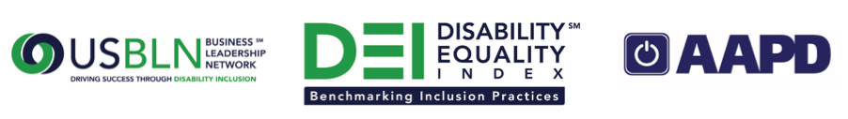

Registration Now Open for Second Annual Disability Equality Index Survey

Washington, D.C. (Sept. 17, 2015) – Today, the US Business Leadership Network® (USBLN®) and the American Association of People with Disabilities (AAPD) are excited to announce the opening of the registration process for the second annual Disability Equality IndexSM (DEISM). Companies that take the DEI self-report on a wide-range of criteria within four categories: Culture & Leadership, Enterprise-Wide Access, Employment Practices, and Community Engagement & Support Services. Eligible companies interested in participating in the second annual DEI must register by Dec. 4, 2015. To register, view the second annual DEI survey questions, or view DEI FAQs, visit: https://disabilityequalityindex.org/deisurvey.

All registered companies will receive access to the second annual DEI survey tool in mid-December 2015. The deadline to submit completed surveys is March 2016. DEI survey scores will be finalized by June 2016.

Companies that participated in the 2014 DEI reported that, “it helped identify areas for improvement that we wouldn’t have thought of otherwise” and described the questions as “thought provoking and straightforward.” Individuals completing the survey on behalf of their companies reported, “in addition to giving me ideas of things to work on, it was an easy conversation starter with individuals in other functions (IT, Communications, etc.).”

The DEI is an aspirational, educational, recognition tool that is intended to help companies identify opportunities for continued improvement and help build a company’s reputation as an employer of choice. Created by leaders in the business and disability communities, the DEI is an online benchmarking tool that offers businesses the opportunity to receive an objective score, on a scale of zero to 100, on their disability inclusion policies and practices.

About the US Business Leadership Network® (USBLN®)
The US Business Leadership Network® (USBLN®) is a national non-profit that helps business drive performance by leveraging disability inclusion in the workplace, supply chain, and marketplace. The USBLN® serves as the collective voice of over 50 Business Leadership Network affiliates across the United States, representing over 5,000 businesses. Additionally, the USBLN® Disability Supplier Diversity Program® (DSDP) is the nation’s leading third party certification program for disability-owned businesses, including businesses owned by service-disabled veterans. www.usbln.org

About the American Association of People with Disabilities (AAPD)
The American Association of People with Disabilities is the nation's largest disability rights organization. AAPD promotes equal opportunity, economic power, independent living, and political participation for people with disabilities. AAPD’s members, including people with disabilities and family, friends, and supporters, represent a powerful force for change. To learn more, visit the AAPD Web site: www.aapd.com.

###

