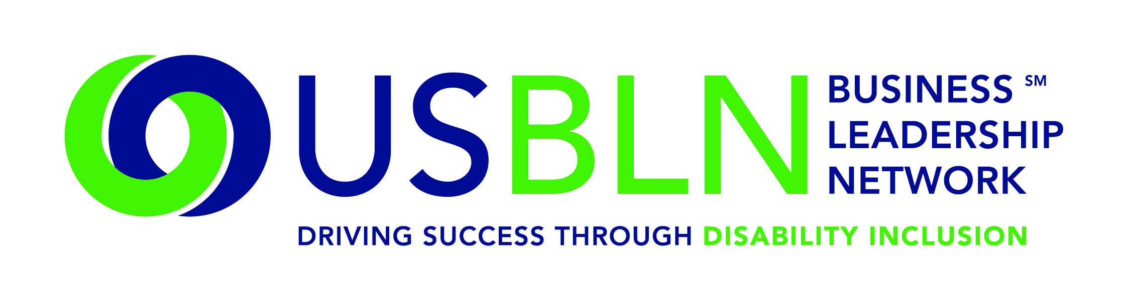

USBLN® Announces New Appointments to its Corporate Advisory Board

For Immediate Release Contact: Anita Howard
February 11, 2015 Phone: (800) 706-2710 anita@usbln.org

WASHINGTON, DC (February 11, 2015) – Today, the US Business Leadership Network® (USBLN®) announced the appointment of five member companies to its Corporate Advisory Board (CAB). The USBLN Board of Directors at its December and January meetings approved inQUEST Consulting, JPMorgan Chase, KPMG LLP, Manpower and Walmart for two-year terms on the CAB. Representing inQUEST is Scott Hoesman who is their CEO & Founder. JPMorgan Chase’s representative is Elizabeth Daly-Torres, who is their Vice-President, Global Diversity Manager. KPMG’s representatives are Christopher L. Brown, CPA and a Partner plus Annette F. Rosta, who is their Associate Director, Recruiting Diversity and Compliance, Experienced Hire Recruiting. Manpower’s representative is Regina Blair who is Director of Diversity and Inclusion, U.S. Russell Shaffer, Senior Manager for Corporate Affairs and Constituent Relations is Walmart’s representative.

The CAB provides a forum for employer representatives to discuss and define their collective needs related to including people with disabilities in the workplace, supply chain and marketplace along with identification of emerging trends in these fields. Its members provide strategic direction to USBLN programs, ensuring a focus on relevant and realistic activities and goals. Additionally, the members contribute an awareness of the business environment, including reports on competitive activities, strategies, and directions to the Board and staff.

"We welcome and appreciate the support and expertise that each of these companies contributes to the USBLN’s expanding programs and many new initiatives. The success of this business-to-business organization results from the pro-active participation of its member companies. We deeply value their support of full inclusion of people with disabilities in the workplace, supply chain and marketplace,” shared Jill Houghton, Executive Director, USBLN.

For more information on the USBLN Corporate Advisory Board, please visit http://usbln.org/about-us_cab.html.

About the US Business Leadership Network (USBLN)
The US Business Leadership Network (USBLN) is a national non-profit that helps business drive performance by leveraging disability inclusion in the workplace, supply chain, and marketplace. The USBLN serves as the collective voice of nearly 50 Business Leadership Network affiliates across the United States, representing over 5,000 businesses. Additionally, the USBLN Disability Supplier Diversity Program® (DSDP) is the nation’s leading third party certification program for disability-owned businesses, including businesses owned by service-disabled veterans. www.usbln.org

####

