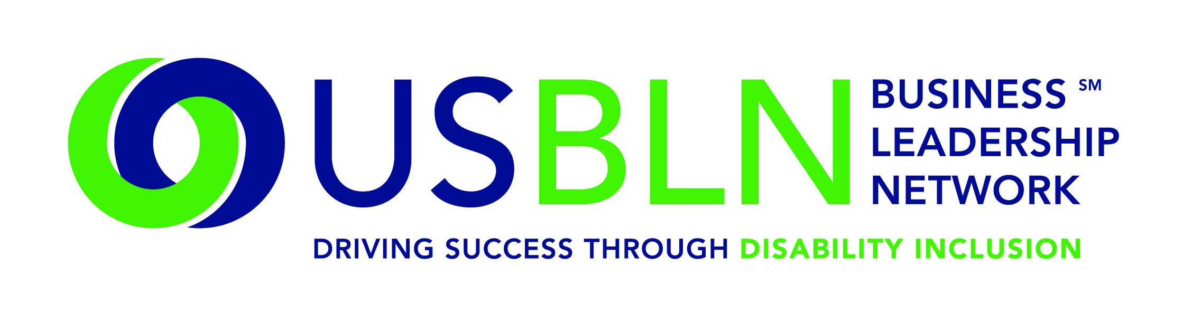

USBLN 18th Annual National Conference Leadership Team Announced

For Immediate Release Contact: Anita Howard
May 27, 2015 Phone: (800) 706-2710 anita@usbln.org

WASHINGTON, DC (May 27, 2015) – Today, the US Business Leadership Network® (USBLN®) announced its 18th Annual National Conference Leadership team. Educational Track Chair representation includes Marketplace Track Chair & Marketplace Program Planning Chair Apoorva N. Gandhi, Vice President, Multicultural Affairs, Marriott International, Inc.; Workplace Track Chair David J. O'Brien, Partner, Brand, Marketing and Communications, Ernst & Young, LLP; Workplace Program Planning Chair Lori Golden, Abilities Strategy Leader, Americas People Team, Ernst & Young, LLP; Supply Chain Track Chair L. Jay Burks, PhD, Senior Manager of Supplier Diversity, Comcast Corporation; and Professional Development Chair Gloria Pualani, Corporate Director, Global Supplier Diversity/Government Relations, Northrop Grumman Corporation. The Disability-Owned Business Enterprise (DOBE®) Host Committee Chair is Joyce A. Bender, Founder and CEO, Bender Consulting Services, Inc. For full biographies of the Conference Leadership team, please visit http://www.usblnannualconference.org/chairs.html.

“Our 2015 Conference Leadership team has shaped our educational programming creating a robust agenda focused on disability inclusion for innovation and growth through talent, supplier diversity and market share. This year’s conference will include an outstanding mix of dialogue sessions, interactive forums and thought-leaders guaranteeing that our educational content is responsive to business’s needs,” said Jill Houghton, Executive Director, USBLN.

Disability-Owned Business Enterprise (DOBE) Host Committee Chair, Joyce A. Bender, Founder and CEO, Bender Consulting Services, Inc. said, “As Chair of the DOBE Host committee, it is my honor to work with the USBLN and other great leaders of Disability-Owned Business Enterprises to advance the message of partnership, value, quality and delivery. We represent the engine of the American economy. When we compete and succeed, we provide important examples of talent, ability and economic empowerment.”

The USBLN’s 18th Annual National Conference & Biz2Biz Expo to be held in Austin, Texas on September 28-October 1, 2015 at the Renaissance Austin hotel. Attendees are invited to join more than 600 senior executives for an unmatched opportunity to learn, network and build business relationships with key leaders of companies that have demonstrated leadership and commitment to disability inclusion. This event will kick-off National Disability Employment Awareness Month (NDEAM) and celebrate the 25th Anniversary of the signing of the Americans with Disabilities Act. Early-bird registration is now available through June 26, 2015, visit: www.usblnannualconference.org

About the US Business Leadership Network (USBLN)
The US Business Leadership Network (USBLN) is a national non-profit that helps business drive performance by leveraging disability inclusion in the workplace, supply chain, and marketplace. The USBLN serves as the collective voice of nearly 50 Business Leadership Network affiliates across the United States, representing over 5,000 businesses. Additionally, the USBLN Disability Supplier Diversity Program® (DSDP) is the nation’s leading third party certification program for disability-owned businesses, including businesses owned by service-disabled veterans. www.usbln.org

####

