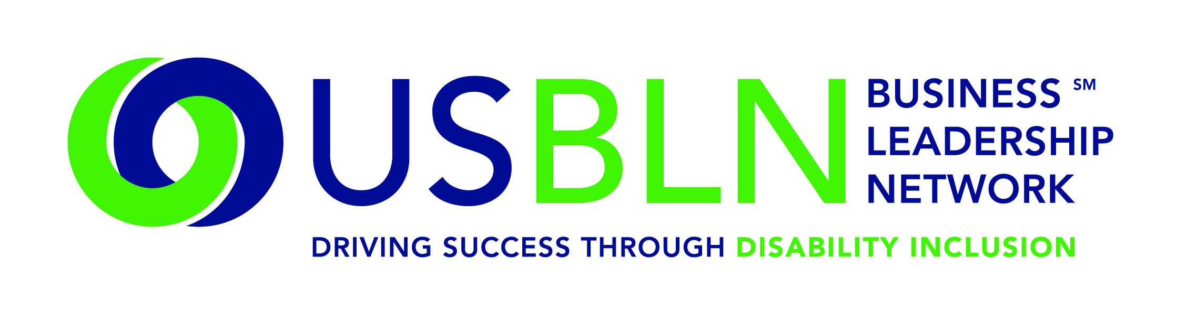

Keith Wiedenkeller Joins the USBLN as Chief Strategy Officer of the
Disability Equality Index (DEI)

For Immediate Release Contact: Anita Howard
April 16, 2015 Phone: (800) 706-2710 anita@usbln.org

WASHINGTON, DC (April 16, 2015) – The US Business Leadership Network® (USBLN®) is pleased to announce that Keith Wiedenkeller, formerly Chief People Officer for AMC Theatres, currently serves in a strategy and consulting role on behalf of the USBLN in its work developing and promoting the ground-breaking Disability Equality IndexSM (DEISM). During his 29-year tenure with AMC, Mr. Wiedenkeller helped develop several cutting-edge diversity initiatives, including the AMC FOCUS program, an outreach program designed to proactively employ hundreds youth with disabilities at AMC’s theatres across the country.

Under Mr. Wiedenkeller’s leadership, the USBLN created its first full-blown, formal strategic plan, enhanced its disability supplier certification program, grew its annual conference by more than 50%, and affected a complete rebranding initiative. As immediate past chair of the USBLN and former Co-chair of the DEI Advisory Committee, Mr. Wiedenkeller was instrumental in the DEI’s design, development, and implementation. A nationally ranked speaker, writer and facilitator known for his practical, win-win approach to disability inclusion, he currently resides in Kansas City, Missouri, with his wife of 32 years and “way too many” dogs.

“I am highly honored to have Keith join us. He is incredibly talented and driven by the mission of our organization and we are very pleased that he has chosen to work with us,” shared Jill Houghton, USBLN Executive Director.

The DEI is a joint initiative of the USBLN and the American Association of People with Disabilities (AAPD). Developed by the DEI Advisory Committee, a diverse group of business leaders, policy experts, and disability advocates, the DEI is a national, transparent benchmarking tool that offers businesses an opportunity to receive an objective score, on a scale of zero to 100, on their disability inclusion policies and practices. It is an aspirational, educational, recognition tool that is intended to help companies identify opportunities for continued improvement and help build a company's reputation as an employer of choice. After the successful completion of the DEI Pilot with 48 Fortune 1000 scope companies in March 2014, the USBLN and AAPD launched the 1st Annual DEI to Fortune 1000 companies in October 2014. The 1st Annual DEI is currently under way.

For more information about the DEI, please visit: https://www.disabilityequalityindex.org/.

About the US Business Leadership Network (USBLN)
The US Business Leadership Network (USBLN) is a national non-profit that helps business drive performance by leveraging disability inclusion in the workplace, supply chain, and marketplace. The USBLN serves as the collective voice of nearly 50 Business Leadership Network affiliates across the United States, representing over 5,000 businesses. Additionally, the USBLN Disability Supplier Diversity Program® (DSDP) is the nation’s leading third party certification program for disability-owned businesses, including businesses owned by service-disabled veterans. www.usbln.org

About the American Association of People with Disabilities (AAPD)
The American Association of People with Disabilities is the nation's largest disability rights organization. AAPD promotes equal opportunity, economic power, independent living, and political participation for people with disabilities. AAPD’s members, including people with disabilities and family, friends, and supporters, represent a powerful force for change. To learn more, visit the AAPD Web site: www.aapd.com

####

