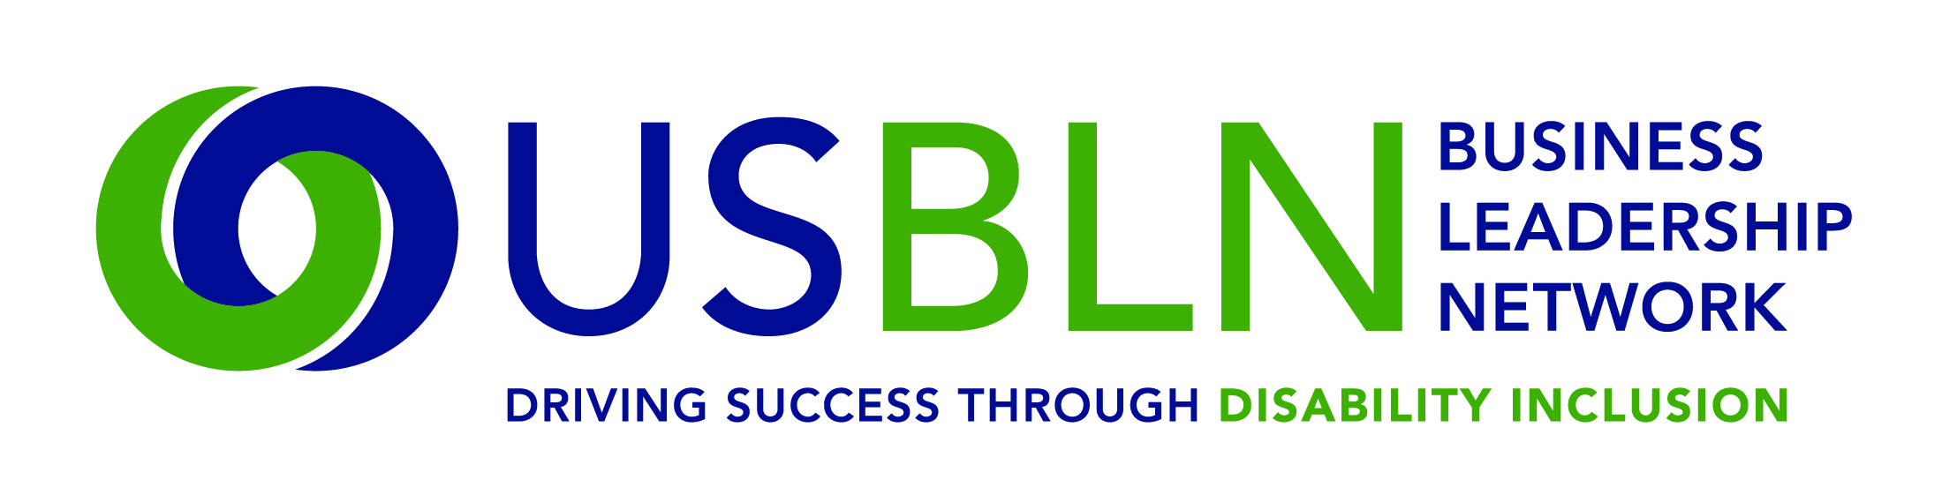

2017 USBLN® ANNUAL LEADERSHIP AWARDS
Supplier of the Year
Nomination Form
(Only Corporate Partners May Nominate Suppliers)

The deadline for submissions is Friday, April 7, 2017 at 5:00 pm EST. Please submit your completed nomination forms to: Adele@usbln.org. Award recipients will be selected by committee and will be announced at the USBLN® 2017 20th Annual Conference & Expo in Orlando, Florida on August 23, 2017. Please note that late nominations will not be accepted.

The “Supplier of the Year” award allows partners to recognize disability suppliers in their supply chain for their performance and customer service.
This award recognizes the USBLN certified Disability-Owned Business Enterprise (DOBE®), Veteran-Disability Owned Business Enterprise (V-DOBE™) or Service-Disabled Veteran Disability-Owned Business Enterprise (SDV-DOBE™) that has provided excellent service and distinguished itself and its business through its business practices and serves as a role model for disability business inclusion in the supply chain.

Note: This award category is specifically designed for business members to nominate deserving disability suppliers in their supply chains.

A Disability-Owned Business Enterprise (DOBE®) is defined as a for-profit businesses that is at least 51 percent owned, managed, and controlled by U.S. citizens whose disability is defined as a physical or mental impairment that substantially limits one or more major life activities; A Veteran-Disability Owned Business Enterprise (V-DOBE™) is defined as a for-profit businesses that is at least 51 percent owned, managed, and controlled by U.S. citizens whose disability is defined as a physical or mental impairment that substantially limits one or more major life activities, who has also has also served in the military; A Service-Disabled Veteran Disability-Owned Business Enterprise (SDV-DOBE™) who has incurred or aggravated a disability while serving in active military naval or air service and whose discharge is documented with a disability ratings letters issued by the Department of Veteran Affairs. Also qualifying are reservists or members of the National Guard when disease or injury was incurred or aggravated in line of duty or while in training status.

Award Criteria below pertains to both DOBE®, V-DOBE™ and SDV-DOBE™ suppliers:
- To qualify, the nominee must be certified by the USBLN® as a DOBE®, V-DOBE™ or a SDV-DOBE™.
- Nominee must participate on USBLN®/DSDP committees, events or other outreach activities that promote disability business engagement and utilization.
- Nominee must consistently network, and when possible, do business with other DOBE®, V-DOBE™ or a SDV-DOBEs™.
- Contribute to the growth and development of DOBE®s, V-DOBE™s and/or SDV-DOBEs™ in society and their community.
- Demonstrate growth in sales and employment.
- Nominating representatives may include supply chain category managers and buyers, corporate business leaders, business leaders, supplier diversity managers/directors/team members, or BLN leaders; self-nominations from DOBE®, V-DOBE™s or SDV-DOBEs™ will not be accepted.
- Nominees will be asked to provide supplementary information as described below to provide a 360 degree perspective (i.e. DOBE®, V-DOBE™, SDV-DOBE™ Nominee Information Form).
- Nominee finalist must be prepared to accept the award that will be presented on Wednesday, August 23rd during the 2017 USBLN® Conference.
- Time period covering actions and activities described in this form shall be from Jan. 1, 2016 through Dec. 31, 2016 (2015 time period for comparison purposes only).
- Nominations can only be submitted by representatives of USBLN®/DSDP corporate members and BLN leaders.
To be completed by the nominating business. Please complete the nomination form in its entirety:
Information on DOBE®, V-DOBE™ or SDV-DOBE™ nominee:

Nominee Name
Title
Organization
Mailing Address
Phone
Email

Contact information of nominating USBLN® Partner responsible for completing this form:

Name
Title
Organization
Mailing Address
Phone
Email

- Why is the nominee deserving of the award “Supplier of the Year” Award? Please submit a brief narrative describing why you feel this nominee is deserving of recognition as Supplier of the Year. You may include specific examples of value that your company has obtained from a relationship with this supplier such as cost reductions, process improvements, and/or high quality products or services, access to key markets, etc. (500 words or less). You may attach your narrative as a separate document when submitting this completed form. Maximum 50 points

- How long has this nominee been a supplier to your firm? ____ years

- What were approximate purchases/percentage changes? 2015_______ ( %) 2016______ ( %)

- What was primary reason for increase (or decrease) in business with the DOBE® or SDV-DOBE™?

- Please use this section to rank the nominee’s performance against their competitors, based on the nominees’ performance compared to other suppliers that offer similar products or services. Maximum 20 points

Rating Scale: Outperforms =2 Comparable =1 Less than = -1 Not Applicable/Unknown = 0

- Quality of products and services _____
- Marketing of products and services _____
- Cost competitiveness _____
- On-time delivery _____
- Contract administration (i.e. invoicing, shipping accuracy) _____
- Problem resolution _____
- Innovation and technology capabilities _____
- Leadership and vision of management team _____
- Overall professionalism _____
- Commitment to diversity and inclusion _____

The nominated DOBE®, V-DOBE™ or SDV-DOBE™ will be required to submit additional information supporting this nomination. (Maximum points 25). The USBLN® will request information such as: how has the DOBE®, V-DOBE™ or SDV-DOBE™ demonstrated growth in sales and employment; two examples of offering high quality products and services competitively using innovation and cost reductions/savings’; buying from other DOBE®s, V-DOBE™ or SDV-DOBE™; and other actions to support the disability community or society as a whole.

Total Points Possible = 100 - 75 points from nominator and 25 points from additional information that nominee will be asked to provide.

PLEASE DO NOT CONVERT FORM TO PDF. The deadline for submissions is 5 p.m. EST on Friday, April 7, 2017. Please submit your completed nomination forms to: Adele@usbln.org. General questions about this submission should be directed to Cami Turcotte at cami@usbln.org. Award recipients will be selected by committee and will be announced at the USBLN® 2017 20th Annual Conference & Expo in Orlando, Fla. on August 23, 2017. Please note that late nominations will not be accepted.

Thank you for submitting your nomination to the
2017 USBLN® Annual Leadership Awards!

