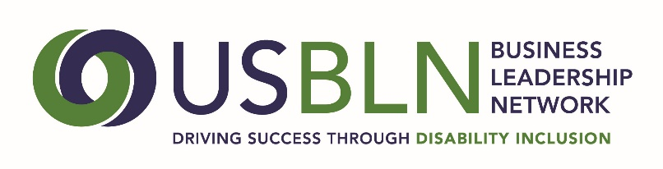
2017 USBLN ANNUAL LEADERSHIP AWARDS
ERG/BRG of the Year Nomination

The ERG/BRG of the Year Award recognizes the one Employee/Business Resource Group at a national, multi-national, or multi-state company with 1000 or more employees that most exemplifies programs, strategies, and initiatives that have resulted in measurable results in the area of disability inclusion in the workplace, marketplace, and supply chain.
For this category, a company must self-nominate. A company must also be a member of the USBLN to be considered for this award.
Note: Employer means all employers except non-profit service providers and government agencies. Since the USBLN recognizes that building a disability-inclusive company is a cumulative effort done over time, the information presented should reflect this and include recognitions and awards received in previous years.
Please complete the nomination form in its entirety:
- Company Name:
- ERG/BRG Name:
3. Contact information of primary company representative to be notified:
Name
Title
Organization
Mailing Address
Phone
Email
Website
4. Contact information of a secondary company representative to contact:
Name
Title
Organization
Mailing Address
Phone
Cell Phone
Email
5. Contact information of person responsible for completing the nomination form:
Name
Title
Organization
Mailing Address
Phone
Email
5. Please provide an overview of the company including founding date, type of industry, mission statement, head quarter’s city and state, whether it is national or multi-national, number of employees in the U.S. and number of employers outside the U.S. (500 words or less)
6. Please describe what the ERG/BRG has done to promote and support the full inclusion of people with disabilities both internally and/or externally. Please provide a specific example(s) of these initiatives and their results. Links to supporting information are encouraged. (2,000 words or less) 85 points
7. Please provide any other supporting information to help the awards committee in the decision-making process. Links to supporting information are encouraged. (1,000 words or less) 15 points

Please do not include any attachments. You may include links in your narrative to supporting information.
PLEASE DO NOT CONVERT FORM TO PDF. Submit your electronic nomination to: Adele@usbln.org General questions about this submission should be directed to Maggie Roffee at maggieroffee@gmail.com.
The deadline for nominee submissions is Friday, April 7, 2017. Award recipients will be selected by committee and will be announced at the USBLN 2017 20th Annual Conference & Expo in Orlando, Fla. on August 23. Please note that late nominations will not be accepted.
Thank you for submitting your nomination to the
2017 USBLN® Annual Leadership Awards!

