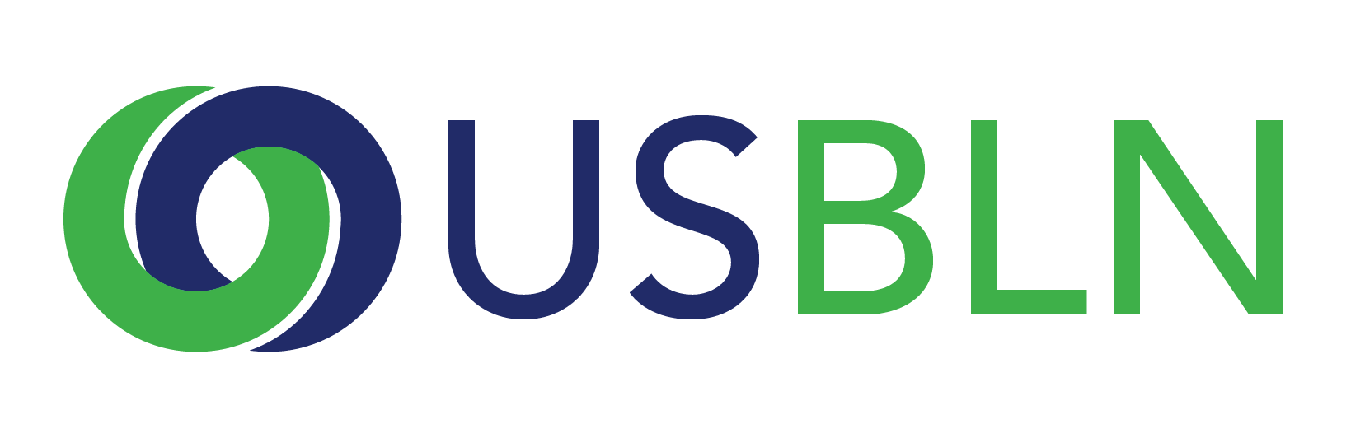
2018 USBLN® ANNUAL LEADERSHIP AWARDS
Affiliate of the Year
Award Nomination Form

THE DEADLINE FOR NOMINATIONS IS
FRIDAY, JANUARY 12, 2018

The "Affiliate of the Year" honors the outstanding Business Leadership Network (BLN) Affiliate that has demonstrated exemplary efforts in promoting the vision, mission and spirit of the USBLN®. As a result of this BLN Affiliate’s efforts, employers and their communities understand, utilize, and benefit from the valuable resources that people with disabilities present in the workplace, supply chain and marketplace. Self-nominations are encouraged.

Please note that if your company is selected to receive this award, you will be asked to submit photos and/or videos to the USBLN for use in an introductory video that will be shown during the award presentation at the 2018 USBLN 21st Annual Conference & Expo. These visuals will need to be submitted 4 weeks after notification. Will you be able to do this? Yes __ No__

*If you have received this award within the past 3 years you are not eligible to apply. Your BLN must be three years old to receive this award.

Award criteria:

An exemplary BLN is:
- A recognized Affiliate of the USBLN® in GOOD STANDING***.
- Business-led.
- Has programming that engages business and resources to foster disability inclusion in the workplace including Supplier Diversity.
- Acts as a pipeline for business to the talent of people with disabilities.
- Promotes people with disabilities as a marketplace resource.
- Is a sustainable model for growth and maturity.

***A BLN Affiliate is a recognized Affiliate of the USBLN® who is in GOOD STANDING with the USBLN®. The requirements to be in GOOD STANDING include the following:
- Non-profit status required: Operating as either a 501c3 or having a documented fiscal sponsor with a signed MOU in place.
- Completed and signed Agreement/ Attachment A.
- Paid 2017 annual dues.
- Submitted a 2016 Annual Report/ supporting documents.

Please complete the nomination form in its entirety and include a roster of your voting BLN board members/steering committee with titles and companies represented.

- Organization Name:
2. Contact information for the primary person to be notified:
Name
Title
Organization
Mailing Address
Phone
Cell Phone
Email
Relationship to BLN
3. Contact information of a secondary person to contact:
Name
Title
Organization
Mailing Address
Phone
Cell Phone
Email
Relationship to BLN

4. Contact information of the person completing the nomination form:
Name
Title
Organization
Mailing Address
Phone
Cell Phone
Email
Relationship to BLN
5. Demonstrate how you are business-led. Specifically, which businesses and other partners participated in the leadership and implementation and growth of your BLN? Your public board/steering committee roster (name of business, name of business rep and role on the BLN governing body- no further contact info necessary) will be considered in this answer.
(1,000 words or less) 20 points
6. Please provide the number of years that your BLN has been in existence and information on how you have developed and grown. Additionally, provide a complete budget for 2016 (a full calendar year) including the breakdown of your operating budget and all sources of income. If you have added additional funding for 2017 please include that this is new funding for 2017. (1,000 words or less) 20 points
7. Please describe the methods by which you connect BLN businesses to a pipeline of qualified individuals with disabilities for employment purposes. (1,000 words or less) 20 points
8. Describe the programs your BLN conducts that makes your Affiliate an outstanding national leader in our network? Please provide the number of businesses/ entities that have benefitted from your programs in 2016 (a full calendar) year.
(1,000 words or less) 20 points Looking specifically to see if your BLN includes Supplier Diversity programming (5 extra bonus points).
9. Why do you believe that your BLN is deserving of the Affiliate of the Year Award? (1,000 words or less) 15 points

10. Please provide any other supporting information to help the awards committee in the decision making process. Feel free to include attachments. (5 points)

PLEASE DO NOT CONVERT FORM TO PDF. Submit your electronic nomination, your voting public board/steering committee member roster and any supporting documents to Adele@usbln.org. General questions about this submission should be directed to: Lynn Kirkbride at lynn@usbln.org.

Award recipients will be selected by committee and will be recognized and receive their awards during the 2018 USBLN 21st Annual Conference & Expo in Las Vegas, Nevada. Please note that late nominations will not be accepted.

THE DEADLINE FOR NOMINATIONS IS
FRIDAY, JANUARY 12, 2018

Thank you for submitting your nomination to the
2018 USBLN® Annual Leadership Awards!

